Chapter 2 p.31

User responses to phish attempts still insufficient

Horizontal bar graph showing the percentage of User responses to phish attempts. It shows Read: 44.6%, No action: 33.3%, Reported: 11.3%, Email link clicked: 7.8%, Credential supplied: 2.3% and Attachment opened: 0.8%.

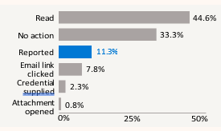

Over the past six months, we found users reported phishing attempts only 11.3% of the time. While no action is better than clicking, reporting phishing attempts would be best to help security teams identify incoming threats.

Source: Microsoft Defender for Office 365 attack

simulation training data